title of the paper
FirstName_Author1 LASTNAME_AUTHOR1
FirstName_Author2 LASTNAME_AUTHOR2

Abstract
The abstract must be between 10 and 20 lines, justify alignment.
Keywords: you must use between 4 and 8 keywords, separated by commas
JEL Classification: you must check the JEL website and use the identifier(s) you consider (https://www.aeaweb.org/econlit/jelCodes.php)

1. Introduction
You MUST abide by the text form rules presented on our website: use single column Envelope B5 pages, i.e., 176 × 250 mm; Times New Roman, 11-point English font; 1.15 between each typed line of the manuscript and the following paragraph spacing - Before: 6 pt, After: 5 pt. Use the following settings for the page margins: Top 1.5 cm, Bottom 1.5 cm, Left 1.75 cm, Right 1.8 cm, Gutter 0 cm, Header and Footer from edge 1.25 cm, Page Vertical alignment Top. The text MUST be justified aligned. [1] All text MUST be only in BLACK FONT COLOR; if you need to emphasize a certain term/concept (which is part of standard text paragraph and not a numbered title/subtitle) transform it to italic or bold fonts. If you insert a bulleted list, you MUST USE ONLY STANDARD black filled circle bullets or empty circles bullets. After the last bullet leave one empty line (press ENTER twice) and then start the next paragraph.
The manuscript title, capitalized, aligned center (on ONE line, if it is longer than one line DO NOT manually insert a new line).
Leave one blank line (press ENTER twice after the title).
The FIRST NAME(s) of the author(s) AND the FAMILY NAME aligned right, with a mandatory footnote mentioning institutional affiliation and an email address (repeat on different lines for each author). Within any volume of JISOM one author cannot be published with more than two articles, and in case of two such occurrences the author(s) lists must be different for each article. All footnotes in the paper MUST be formatted with TIMES New Roman, 9 points, single line, left-aligned
Leave one blank line (press ENTER twice after the title).
Write "Abstract", in bold letters, then press ENTER to move to the next line. Insert the abstract, justify alignment, between 10 and 20 lines. Leave one blank line (press ENTER twice after the abstract).
Write "Keywords:", in bold letters, and insert your key words, between 4 and 8 (standard font, NOT bold), then press ENTER once.
Write "JEL Classification:", in bold letters (you must be on the next line after the key words) [2] and insert the JEL codes (see here) (standard font, NOT bold), then press ENTER twice.
If you insert pictures/graphics/tables please name them “Figure/Table/Graphic X. …(explanation)”, with this caption positioned under the picture, centered. When inserting a figure do not leave a blank line before – just press ENTER at the end of the previous line to start a new paragraph, leave NO blank line between the picture and the legend – just press ENTER after the picture, insert the figure number and short description, and press ENTER twice after the caption. If you have to mention the source of the picture, please do it with a footnote. All pictures/tables/graphics must be formatted as “in line with text”, horizontally centered, and NOT WIDER than the width of the standard text paragraph [3]. DO NOT CREATE IMAGES from MS Word symbols/shapes/etc. insert only JPG/PNG/GIF PICTURES.

If the figure/table/graphic is obtained from another source, this MUST be mentioned in footnote attached to the figure/table/graphic caption. Please consider the example:
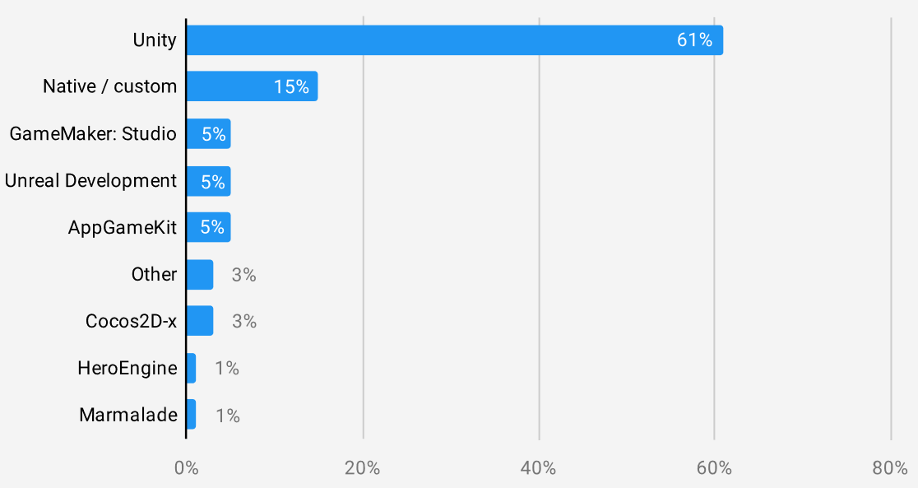
Figure 1. A very interesting chart

Table Header 1 | Table Header 1 | Table Header 1 | Table Header 1
Content 1 | 10 | 20 | 30
Content 2 | 40 | 50 | 60
Table 1. An extremely important and relevant table

At the end of the section PRESS ENTER 3 TIMES (=leave 2 blank lines) then start the next section of the paper [4].

2. Section 2
2.1 Sub-section 2.1
If you use subsections, please follow the draft regulations: if you start right after the section declaration, just place the subsection on the next paragraph, if you have a content for the section and then insert a subsection leave 1 (one) empty paragraph above and below the subsection (see below).

3. Section 3
Please abide exactly by the above regulations.

3.1. Subsection 3.1
Please abide exactly by the above regulations.

3.2. Subsection 3.2
Please abide exactly by the above regulations.

4. Section 4
Please abide exactly by the above regulations.

5. Conclusions
You MUST end with your own summarizing conclusions regarding the paper’s chosen topic(s).
AFTER this section, please press ENTER 3 TIMES and write “References”, WITHOUT numbering the section. Then press ENTER once and insert the paper’s references like the below structure, in order of the referral appearance in the paper. Press ENTER after each numbered reference.

Acknowledgment
If you need to insert an acknowledgment text within your paper insert it here, as the last, unnumbered section, before the References section. Insert it after leaving 2 (two) empty paragraphs before the Acknowledgment subtitle.

References
Leave 2 (two) empty paragraphs before the References section (which is NOT numbered but it IS MANDATORY). The References section is to be LEFT-ALIGNED.
Please pay attention to this section! – references are used to document and substantiate statements made in the paper. Each reference inside this section must be mentioned, with the corresponding number between square brackets [XX], inside the paper! Each article must list R references, where R >= 5.

[1] Author-1, Author-2, […] - Paper Title (Italic) - Journal. ISBN/ISSN. [page AA-BB]. [month-date] Year
[2] John DOE, Jane DOE, Will SMITH - A Great Title for An Article - Journal of Interesting Papers, volume 1 no. 1. ISSN 12345678901. April 2020
[3] Author-1, Author-2, […] - Book Title (Italic) - [page AA-BB]. ISBN. Publisher. [month-date] Year.
[4] Jim DIM, Jana DUM, Adam SUM - A Nice Title for A Book - Pages 171-178, 204, 225-229. ISBN 199888777666. Published by ABC PrintingHouse. 2021
[5] online resource without credited author. Couple descriptive words. Date of last access as DD-MM-YYYY
[6] https://www.invasion.ua - Recent statistics on the russian savage crimes in Ukraine. 24-02.2022

Bibliography
Leave 2 (two) empty paragraphs before the Bibliography section (which is NOT numbered but it IS MANDATORY).
Please pay attention to this section! – A bibliography is a list of all the sources you used to generate your ideas about the topic, INCLUDING those already cited in the References section, as well as those you did not cite directly! Each article must list B bibliography titles, where B >= R+5 (see References details for R), alphabetically ordered by the family name of the first author - online only resources, like websites, should be listed AFTER the regular titles (books, articles, etc.), in alphabetical order of the website name.
The Bibliography section is to be LEFT-ALIGNED.

Author A-1, Author A-2, […] - Paper Title (italic) - Journal ISBN/ISSN. [page AA-BB]. [month-date] Year
ABRAMS Tank, ANDERSON R.P.G., THOMSON A. - A Great Title for An Article. Journal of Interesting Papers, volume 1 no. 1. ISSN 12345678901. April 2021
ALTAIR A. - Book Title (Italic) - [page AA-BB]. ISBN. Publisher. [month-date] Year.
BARNABY J, ANDERSON T., JULES H. - A Great Title for Another Article. Journal of Interesting Papers, volume 1 no. 1. ISSN 12345678901. April 2020
CARDIGAN R., ANTONY B. – Very Nice Book – ISBN 123-4567890. Best Publishing House. June 2022
online resource without credited author. Short descriptive phrase. Date of last access as DD-MM-YYYY
https://www.invasion.ua - Recent statistics on the terrorist russian savage crimes in Ukraine. 24-02.2022
https://www.rau.ro - RAU’s official website. 20.06.2022

PhD Status, Position of Author-1, Institutional affiliation of Author-1, Country, email of author-1
PhD Status, Position of Author-2, Institutional affiliation of Author-2, Country, email of author-2
Source: https://create.unity3d.com/2021-game-report
IF there is an external source to be cited for the table, do it as footnote: Source: https://www.nicetables/com

